-------------------------------------------------------------------------------------------------------------------------------NAME: ARCHANA DEVI.P
REG NO: 192521192
COURSE: SOFTWARE TESTING
CODE: CSA0923
LAB PROGRAMS
Question 21: Check Whether a Number Is Prime Using Junit

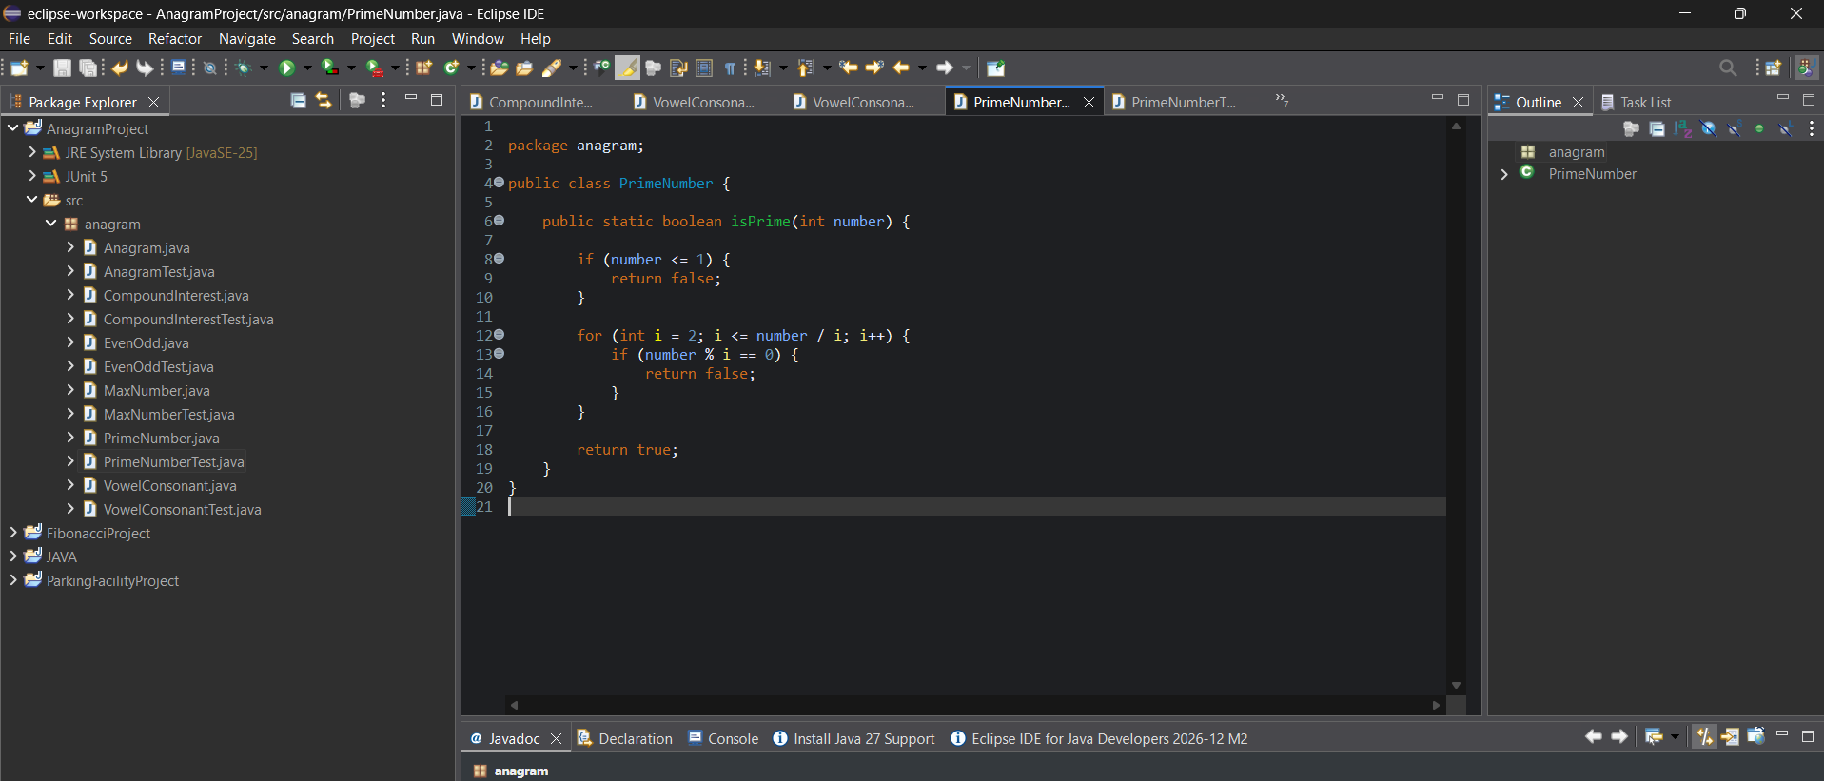

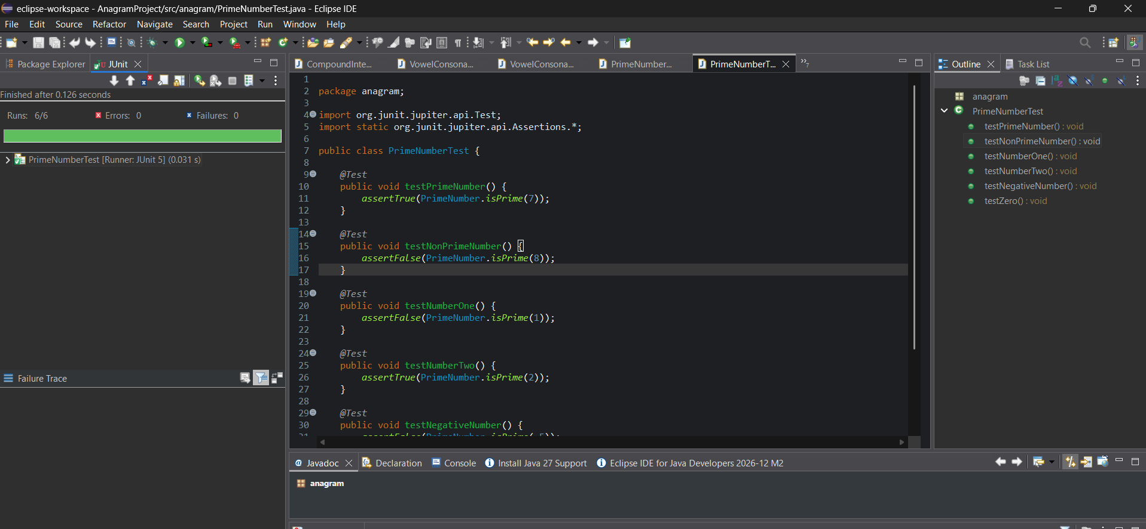
White-box testing
These tests check the internal decision paths:
- Number less than or equal to 1.
- Number divisible by another number.
- Number with no divisors other than 1 and itself.
- The smallest prime number, 2.
Result : The prime number program was implemented and tested using JUnit 5. Six test cases verify prime and non-prime numbers, zero, one, and negative numbers.

